Pre-Lab Questions
- What are chromosomes made of?
- Research the differences between mitosis and binary fission. Identify at least one difference and explain why it is significant.
- Cancer is a disease related to uncontrolled cell division. Investigate two known causes for these rapidly dividing cells and use this knowledge to invent a drug that would inhibit the growth of cancer cells.

Experiment 1: Observation of Mitosis in a Plant Cell

Result Tables
Table 1: Mitosis Predictions
Predictions
Supporting Evidence

Table 2: Mitosis Data
Stage | Number of Cells in Stage | Total Number of Cells | Calculated % of Time Spent in Each Stage
Interphase
Prophase
Metaphase
Anaphase
Telophase
Cytokinesis

Table 3: Stage Drawings
Cell Stage | Drawing
Interphase
Prophase
Metaphase
Anaphase
Telophase
Cytokinesis

Post-Lab Questions
- Label the arrows in the slide image below with the appropriate stage of the cell cycle.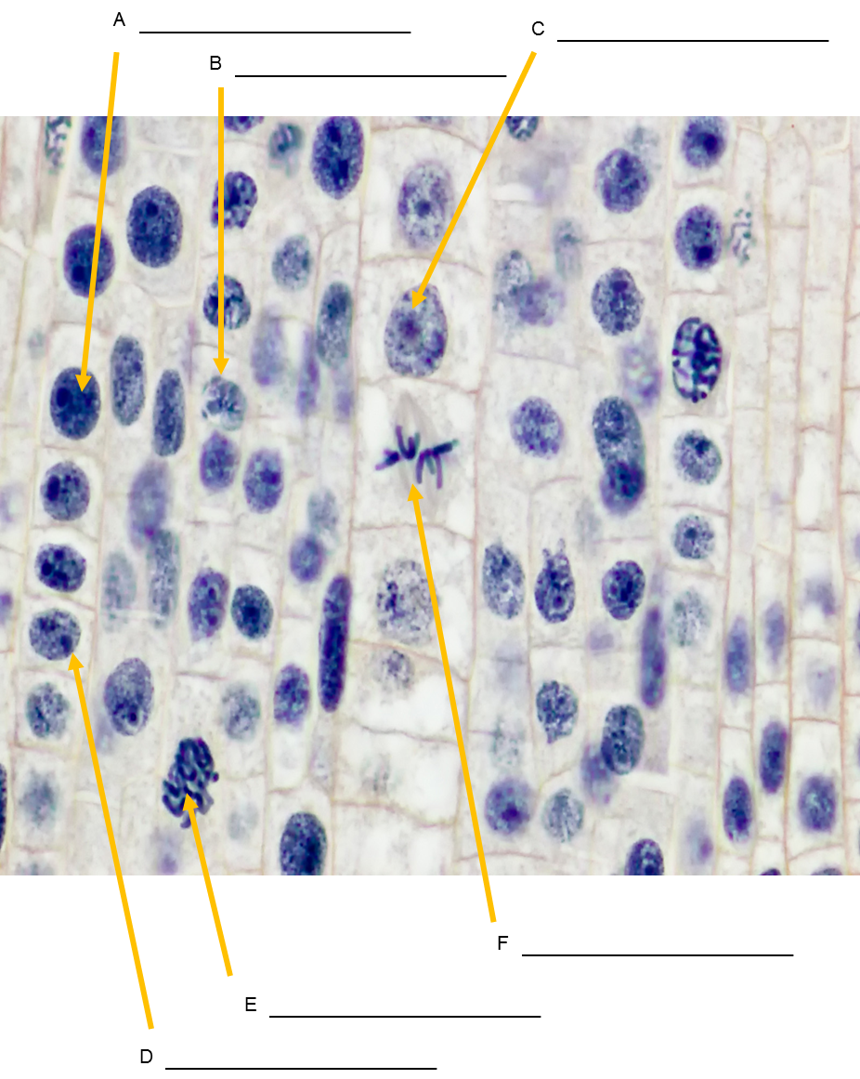
A:
B:
C:
D:
E:
F:
- In what stage were most of the onion root tip cells in? Based on what you know about cell cycle division, what does this imply about the life span of a cell?
- Were there any stages of the cell cycle that you did not observe? How can you explain this using evidence from the cell cycle?
- As a cell grows, what happens to its surface area to volume ratio? (Hint: Think of a balloon being blown up). How does this ratio change with respect to cell division?
- What is the function of mitosis in a cell that is about to divide?
- What would happen if mitosis were uncontrolled?
- How accurate were your time predictions for each stage of the cell cycle?
- Discuss one observation that you found interesting while looking at the onion root tip cells.

Experiment 2: Tracking Chromosomal DNA Movement Through Mitosis

Cell Cycle Division: Mitosis Beads Diagrams
Prophase
Metaphase
Anaphase
Telophase
Cytokinesis

Post-Lab Questions
- How many chromosomes did each of your daughter cells contain?
- Why is it important for each daughter cell to contain information identical to the parent cell?
- How often do human skin cells divide? Why might that be? Compare this rate to how frequently human neurons divide. What do you notice?
- Hypothesize what would happen if the sister chromatids did not split equally during anaphase of mitosis.

Experiment 3: The Importance of Cell Cycle Control

Data
1.
2.
3.
4.
5.

Post-Lab Questions
- Record your hypothesis from Step 1 in the Procedure section here.
- What do your results indicate about cell cycle control?
- Suppose a person developed a mutation in a somatic cell that diminishes the performance of the body’s natural cell cycle control proteins. This mutation resulted in cancer, but was effectively treated with a cocktail of cancer-fighting techniques. Is it possible for this person’s future children to inherit this cancer-causing mutation? Be specific when you explain why or why not.

